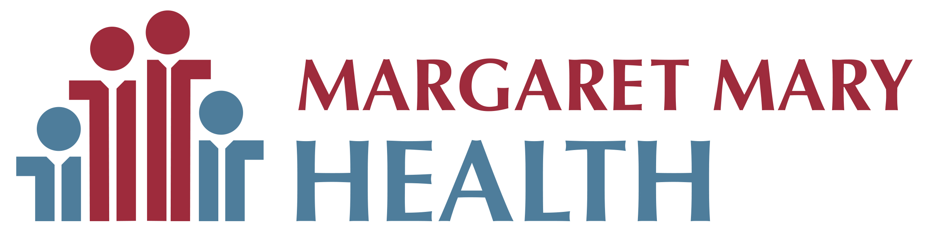

PRESS RELEASE FOR IMMEDIATE PUBLICATION

Date: November 7, 2024
Contact: Jonathon Maple, MMHF Executive Director
(812) 933-5141

MMHF Awards Eight Grants

In 2024, Margaret Mary Health Foundation awarded eight grants, totaling more than $50,000, to Margaret Mary Health. Made possible by the generous donations of MMHF supporters, the grants included:

- Ergotron medical carts to be used as mobile workstations in the emergency services department
- Powered Air-Purifying Respirator masks to protect caregivers at the cancer center
- Inpatient supplies for hospice patients
- A mannequin for pediatric care training
- A Tono-Pen to be used in the emergency services department to assess pressure inside the eye
- A refrigeration unit for vaccines in the occupational health department
- A bladder scanner for the emergency services department
- Benches for patients at MMH’s Medical Arts Center

“These grants benefit both patients and caregivers in nearly every area of our hospital, and we are pleased to see the community’s donations in action,” said Jonathon Maple, MMHF Executive Director. “Our goal is to find new ways to enhance the patient experience at Margaret Mary, and we are grateful for our supporters who allow us to fulfill this mission.”

To help MMHF continue its mission of improving patient care for future generations, contact Jonathon Maple at 812-933-5141 or Jonathon.maple@mmhealth.org.

###

Photo Cutline:
Happy Grant Recipients: (Front row, from left) Katie Grossman, Primary Care Manager; Krista Herd, Hospice Manager; Mandy Bolos, ESD Manager; Geralyn Litzinger, Director of Community Health Improvement (Second row, from left) Chad Hartsock, Safety Coordinator; Vickie Raible, Director of Acute Care; Liz Linville, Director of Outpatient Clinic and Oncology and Jonathon Maple, Executive Director of Margaret Mary Health Foundation

